* 1. Set Up and Create a Git Repository



This section will guide you to:

* Download Git from the official website and configure it
* Generate files, initialize .git directory, and commit the files

This guide has four subsections, namely:

1.1.1 Downloading Git from the official website for your operating system

1.1.2 Configuring Git in your system

1.1.3 Generating files and initializing the .git directory

1.1.4 Executing the basic commands

* Git is already installed in the labs. (Refer MEAN: Lab Guide - Phase 1)
* If you want to use Git with the software on your Windows system, then follow the below steps:

**Step 1.1.1:** Downloading Git from the official website for your operating system.

* Open your Chrome browser and navigate to <https://git-scm.com/downloads> page of Git. Click on the **Download <Version_Number> for Windows** button available on the right side of the screen as shown in the screenshot below:

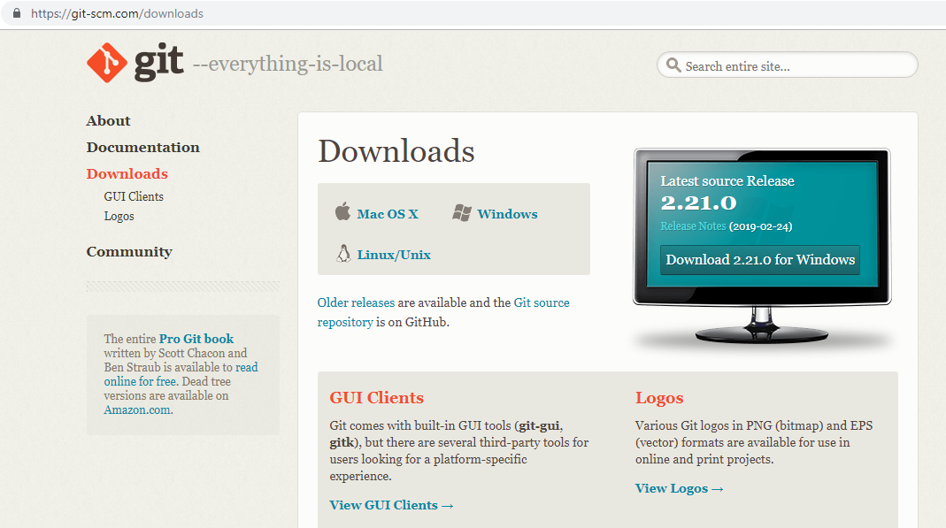

**Step 1.1.2:** Configuring Git in your system.

* Locate the downloaded git.exe file.
* Right click on the executable git file and select **Run as administrator**
* Once you accept the installation request, you will be directed to the **Information** window. Click on the **[Next >]** button.
* Do not make any changes and click on **[Next >]** button.
* You will be prompted to select the default editor used by Git. Select **Use Vim (the ubiquitous text editor) as Git’s default editor** and click on **[Next >]** button.
* You will be prompted to select how to use Git. Select **Git from the command line and also from 3rd – party software** and click on **[Next >]** button.
* You will be prompted to select the HTTPS transport backend. Select **Use the OpenSSL library** and click on **[Next >]** button.
* You will be prompted to select a style to treat the line endings in text files. Read the options and select the one that is suitable for your preference. Click on the **[Next >]** button.
* You will be prompted to select the terminal emulator. Read the options and select the one that is suitable for your preference. Click on the **[Next >]** button.
* You will be prompted to choose the features to enable. Do not make any changes and click on the **[Install]** button.

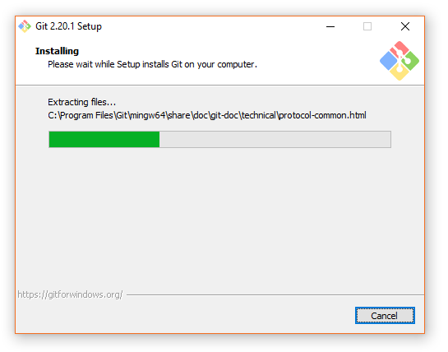

**Step 1.1.3:** Generating files and initializing the .git directory.

* Create a folder on your desktop and open it.
* Create the files: hello.js, index.html, and helloWorld.java
* Open the Git terminal and navigate to the folder you have created.
* Execute the following command to initialize the .git repository:

**git init**

**Step 1.1.4:** Executing the basic commands.

* Add all the files to your git repository using the following command:

**git add .**

* Commit the changes using the following command:

**git commit -m . “Changes have been committed.”**